July 3, 2018

Professor Aron Culotta
Editor, JMLR
Illinois Institute of Technology, USA

Dear Professor Culotta:

Enclosed please find a manuscript entitled “A Neural Network-Evolutionary Computation Framework for Remaining Useful Life Estimation” by David Laredo, Zhaoyin Chen, Dr. Oliver Schütze and myself. I would like to submit the manuscript, with the consent of all the mentioned authors, to JMLR for publication consideration as a regular paper. I would like to suggest the following JMLR action editors for the handling of the manuscript:
- Tong Zhang
- Luis Ortiz
- Marc Schoenauer
I also declare that this paper has never been published elsewhere before.

Thank you for handling the manuscript.

Sincerely,
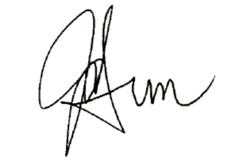

Jian-Qiao Sun, Ph.D., P.E., Fellow-ASME
Professor of Mechanical Engineering

